***INFORMATION ON 3rd GENERATION COMPUTER***

***The period of third generation was from 1965-1971. The computers of third generation used Integrated Circuits (ICs) in place of transistors. A single IC has many transistors, resistors, and capacitors along with the associated circuitry.***

***The IC was invented by Jack Kilby. This development made computers smaller in size, reliable, and efficient. In this generation remote processing, time-sharing, multiprogramming operating system were used. High-level languages (FORTRAN-II TO IV, COBOL, PASCAL PL/1, BASIC, ALGOL-68 etc.) were used during this generation.***

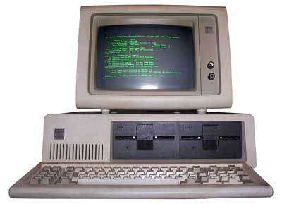

***The main features of third generation are −***

* ***IC used***
* ***More reliable in comparison to previous two generations***
* ***Smaller size***
* ***Generated less heat***
* ***Faster***
* ***Lesser maintenance***
* ***Costly***
* ***AC required***
* ***Consumed lesser electricity***
* ***Supported high-level language***

***Some computers of this generation were −***

* ***IBM-360 series***
* ***Honeywell-6000 series***
* ***PDP (Personal Data Processor)***
* ***IBM-370/168***
* ***TDC-316***
* 